1: RegEX Symbols in Linux List them down with description

### **1. Using "." (dot) to match strings.**

Using "." we can find a string if we do not know the exact string, or we just remember only the start and end of the string, we can use "."

==We can find the string even if we don’t know about it

2. Using "^" (caret) to match the beginning of the string Using "^", we can find all the strings that start with the given character.

==Using caret we can find the strings starts with the particular character which is provided.

### 3. Using "$" (dollar sign) to match the ending of the string Using "$" we can find all the strings that end with the given character

|  |
| --- |
|  |

### 4. Using "*" (an asterisk) to find any number of repetitions of a string Using "*", we can match up to zero or more occurrences of the character of the string

### ==Used to find the specific letters which are repeated in the string

### 5. Using "\" (a backslash) to match the special symbol Using "\" with special symbols like whitespace (" "), newline("\n"), we can find strings from the file

### == If we want to search for special characters like semicolon (;), colon (:), slashes (/), comma (,) and many more, we use the expression ‘backslash’.

### 6 Using "()" (braces) to match the group of reg exp. Using "()", we can find matched strings with the pattern in the "()".

### 7. Using "?" (question mark) to find all the matching characters Using "?", we can match 0 or 1 repetitions of the preceding.

### Linux OS.. can you tell me the feature of Linux.

### ==Linux is a operating system .it a open source , it provides the security , stability, it allows the customization . it provides the portability supported by the wide range of the system , hardware support . It provides Multiuser and Multitasking.

What is Kernel ? can you explain about it in your words..

==It acts as bridge between the operating system and the hardware . The kernel manages system resources, such as the CPU, memory, and devices, ensuring everything works together smoothly and efficiently. It handles tasks like running programs, accessing files, and connecting to devices like printers and keyboards.

Q } BASH in Linux full form and Explanation

== Bash is a command-line interpreter or Unix Shell and it is widely used in GNU/Linux Operating System. Scripting is used to automate the execution of the tasks so that humans do not need to perform them individually.

Q } Now that you know Linux is also an Operating System like Windows. What do you think is the difference between Linux and Windows.

== Linux is open source operating system . which through the windows is not the public based operating system (we need to buy the windows key of the activation for using the complete features of the operating system)

==Linux have high level of customization where as the windows don’t have it.

==Linux is free source any on can download while windows need the activation key

Q }What are the basic components of Linux? Describe each in detail with diagrams.

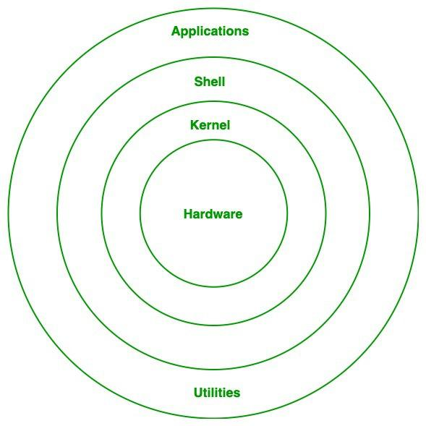

==[Kernel](https://www.geeksforgeeks.org/introduction-to-linux-operating-system/) is the main core component if Linux, it controls the activity of other hardware components.

==[Shell](https://www.geeksforgeeks.org/introduction-linux-shell-shell-scripting/)can be determined as the interface to the kernel, which hides the internal execution of functions of kernel from the user.

==Hardware layer of Linux is the lowest level of operating system track. It is plays a vital role in managing all the hardware components. It includes device drivers, kernel functions, memory management, CPU control, and I/O operations.

== System utilities are the commend line tools that preforms various tasks provided by user to make system management and administration better. These utilities enables user to perform different tasks, such as file management, system monitoring, network configuration, user management etc.

==System libraries are some predefined functions by using which any application programs or system utilities can access kernel's features. These libraries are the foundation upon which any software can be built.

Q}Is it legal to edit Kernal ? when do you think we have to in case?

==Yes, it is legal to edit a kernel, particularly the Linux kernel, as it is licensed under the General Public License (GPL). The GPL allows for modification and redistribution, so long as the original source code is provided.

Q} What is LILO? Explain

LILO stands for Linux Loader that is used to load Linux into memory. It can boot operating systems from floppy disks, hard disks, and it does not depend on a specific file system. Lilo handles some tasks such as locate the kernel, identify other supporting programs, load memory and starts the kernel

Q} What is swap space?

==Swap space is a portion of the hard disk that is used as virtual memory when the system’s RAM (physical memory) is full.

Q} What is Mount ? how do you mount and unmount file system in Linux?

==In **Linux, mounting** is the process of **attaching a filesystem** (like a hard drive, USB, ISO, etc.) to a directory in the **existing directory tree** so that you can access its files.

Q} What is shell? How many shells are there and what are they ? can you explain.

==A shell is a command-line interface (CLI) that allows users to interact with the operating system by typing commands. It acts as a bridge between the user and the kernel — taking your input, interpreting it, and executing it. There are 7 types shell in Linux

• **Bash**: (Bourne Again Shell) Great for scripting and standard usage.

• **Zsh** (Korn Shell): Perfect for developers who want themes, autocomplete, and customization.

• **Fish**: Ideal for beginners and modern workflow.

• **Sh** (Bourne Shell): Good for lightweight or legacy systems.

• **Ksh/ Csh/ Tcsh**: Often used in enterprise or legacy Unix systems.

What is chmod command ? how to use it?

The chmod (short for **change mode**) command is used to **change the permissions** of a file or directory in Linux.

Can you add a new user account? Crate a new user in different ways and paste ss

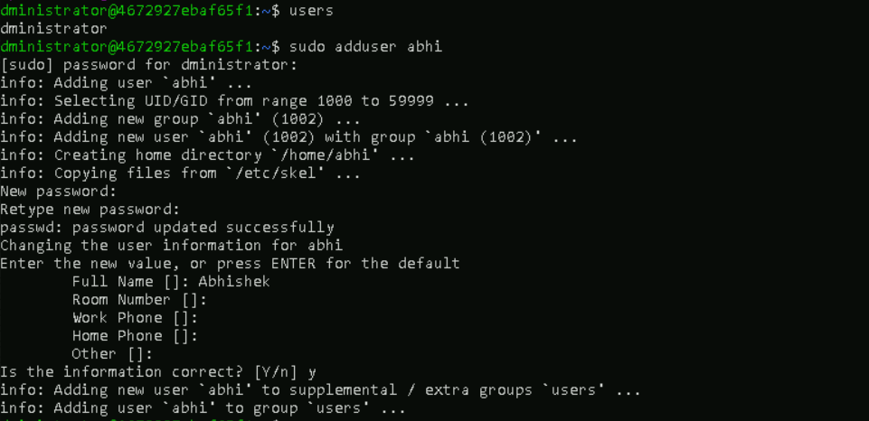

Can you change the password of a user?

How do you do that? Plz share ss

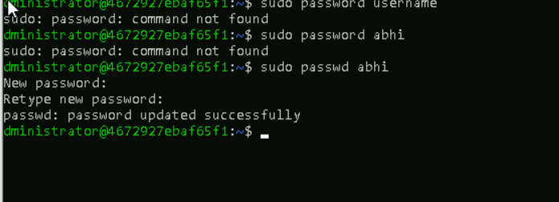

What is diff between Process and Thread?

### ==A process is a program in execution, while a thread is a unit of execution within a process. Processes are independent, with their own memory space, while threads within the same process share memory and resources. Threads are lighter than processes, meaning they require fewer resources and have faster context switching

## 1. Case insensitive search

The -i option enables to search for a string case insensitively in the given file. It matches the words like "UNIX", "Unix", "unix".

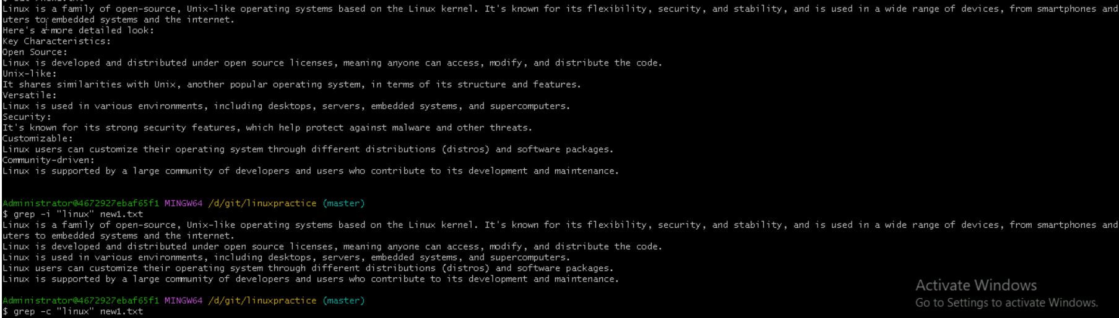

## 2. Displaying the Count of Number of Matches Using grep

We can find the number of lines that matches the given string/pattern 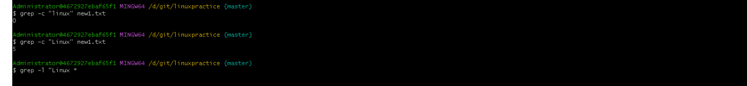

## 3. Display the File Names that Matches the Pattern Using grep

We can just display the files that contains the given string/pattern.

## 4. Checking for the Whole Words in a File Using grep

By default, grep matches the given string/pattern even if it is found as a substring in a file. The -w option to grep makes it match only the whole words.

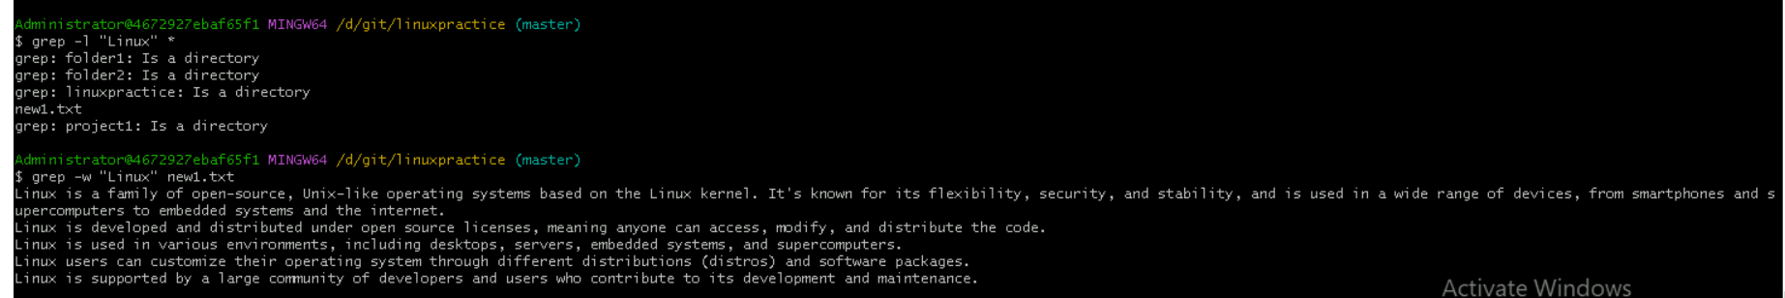

## 5. Displaying only the matched pattern Using grep

By default, grep displays the entire line which has the matched string. We can make the grep to display only the matched string by using the -o option.

## 6. Show Line Number While Displaying the Output Using grep -n

To show the line number of file with the line matched.

## 7. Inverting the Pattern Match Using grep

You can display the lines that are not matched with the specified search string pattern using the -v option.

## 8. Matching the Lines that Start with a String Using grep

The ^ regular expression pattern specifies the start of a line. This can be used in grep to match the lines which start with the given string or pattern.

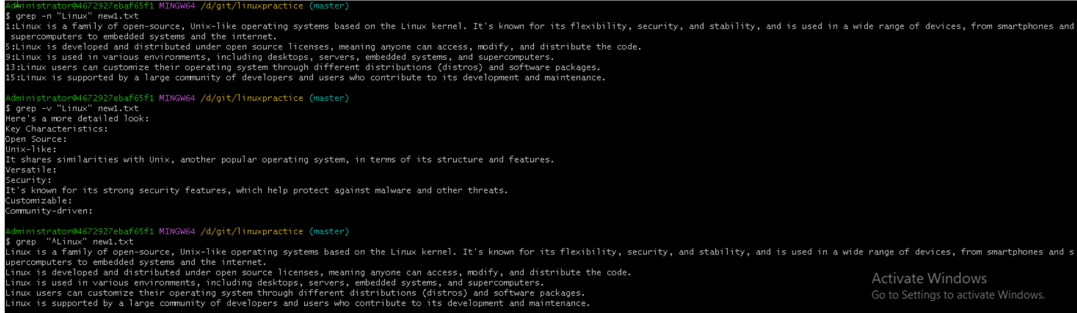

## 9. Matching the Lines that End with a String Using grep

The $ regular expression pattern specifies the end of a line. This can be used in grep to match the lines which end with the given string or pattern.

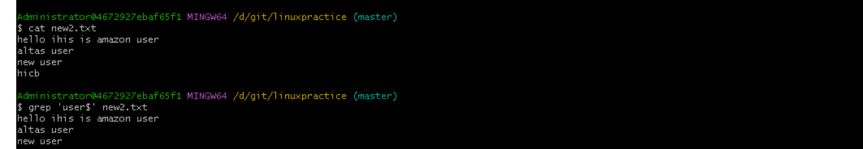

## 10.Specifies expression with -e option

Can use multiple times :



## 11. -f file option Takes patterns from file, one per line

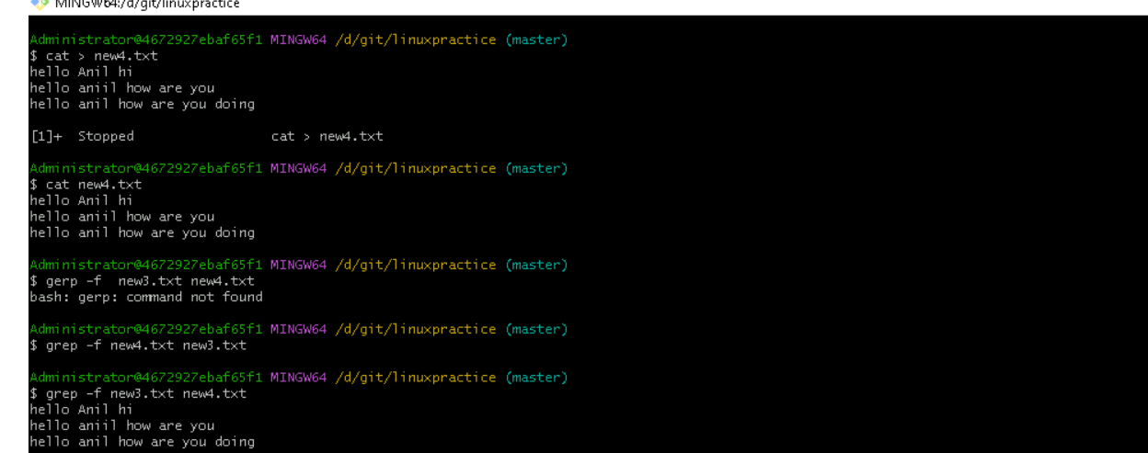

## 12. Print n Specific Lines from a File Using grep

-A prints the searched line and n lines after the result, -B prints the searched line and n lines before the result, and -C prints the searched line and n lines after and before the result.

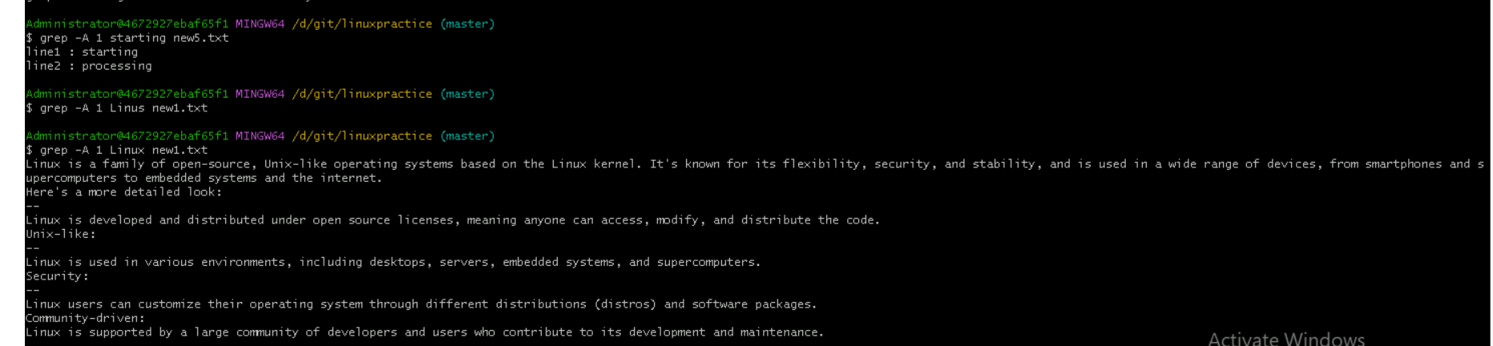

## 13. Search Recursively for a Pattern in the Directory

**-R**prints the searched pattern in the given directory recursively in all the files.



AWK COMMANDS

### 1.  Print Contents of a File

### 2: Print Specific Columns of a File

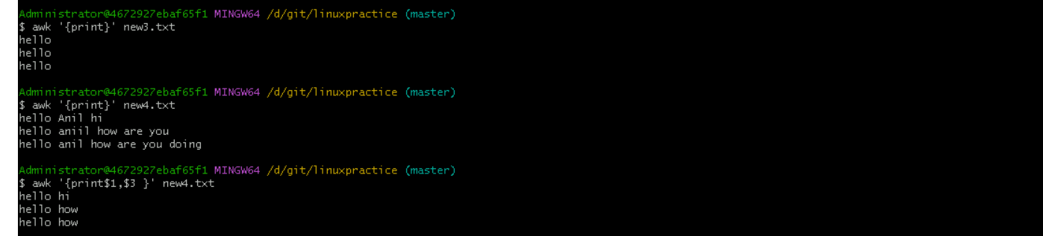

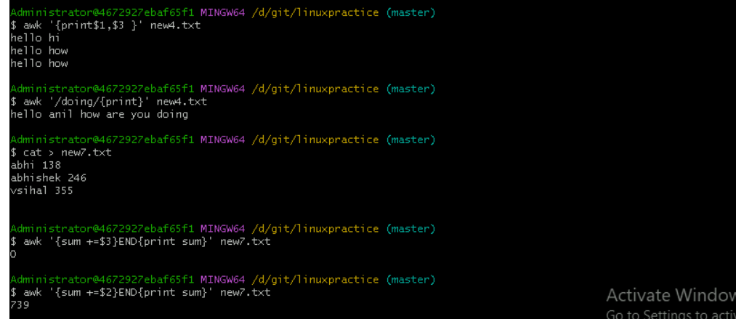

### Example 6: Join Two Files Based on a Common Column

